CARCASSONNE
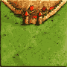 | 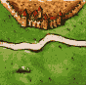 | 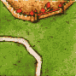 | 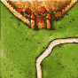 | 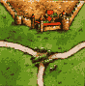
5 | 3+tuile départ | 3 | 3 | 3
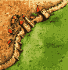 | 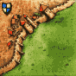 | 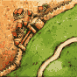 | 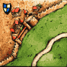 | 
3 | 2 | 3 | 2 | 3
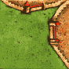 | 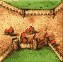 | 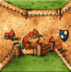 | 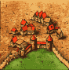 | 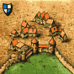
2 | 1 | 2 | 3 | 1
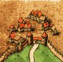 | 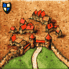 | 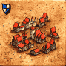 |  | 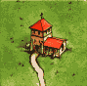
1 | 2 | 1 | 4 | 2
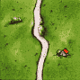 | 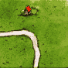 | 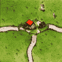 | 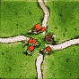
8 | 9 | 4 | 1

